Abstract
Stick-nest rat (Leporillus) middens provide a rare source of Quaternary ecological data in arid Australia, but most known examples are Holocene-aged, limiting their relevance for understanding Pleistocene ecosystems. This study evaluates whether climate-informed species distribution models (SDMs) can predict the locations of older middens by reconstructing the historical ranges of Leporillus apicalis (extinct) and L. conditor (extant). Ensemble SDMs were developed from historical and subfossil records and hindcasted from 40,000 years ago to the present at 1,000-year intervals. Both species showed southward range shifts following the Last Glacial Maximum but differed in spatial extent and climate responses: L. apicalis exhibited broader thermal tolerance and more continuous east–west habitat, while L. conditor remained more restricted but persisted under lower rainfall. Model predictions were compared with 57 dated midden sites withheld from training. Validation scores were moderate, but spatial clustering of midden locations likely introduced pseudo-absence bias, limiting the interpretability of these metrics. However, midden appearance in each region closely matched the onset of predicted suitability, supporting the reconstructed range shifts. These findings highlight the potential for climate-informed species distribution models to support the discovery of new midden sites by identifying areas where preserved Pleistocene records are more likely to occur.
Key words: Species distribution models, habitat suitability modelling, palaeoenvironment, Quaternary palaeoecology, rodent middens, Pleistocene refugia, arid Australia, Australian Pleistocene, Leporillus, stick-nest rats

Introduction
The Quaternary period began 2.58 million years ago (Head, 2019), and is characterised by repeated glaciation cycles lasting approximately 100,000 years (Elias, 2013; Gibbard & Head, 2020). Glacial periods occur when temperatures drop and large volumes of water become trapped in ice sheets, lowering sea levels. In contrast, interglacial periods bring warmer, often wetter conditions and rising sea levels due to glacial melt. These fluctuations have profoundly shaped ecosystems and species distributions, as land is alternately exposed and submerged, driving migrations, isolations, and the creation or loss of habitat (Elias, 2013).
Glacial periods—and the cooler interstadial phases between them—make up around 85–90% of the Quaternary (Elias, 2013; Pillans & Gibbard, 2012). Each glacial cycle includes a long phase of progressive cooling and increasing ice volume, typically culminating in a peak of maximum glaciation (e.g. the LGM at ~21 ka) (Clark et al., 2009), followed by a relatively brief interglacial (Lisiecki & Raymo, 2005). Interglacial periods such as the Holocene represent only 10–15% of each cycle and may produce ecological communities that are unrepresentative of long-term Quaternary conditions (Hope, 1994).
Although interglacials can appear more hospitable, they occur within a broader climatic context dominated by cold, dry glacial phases. All surviving Quaternary organisms have persisted under these prevailing conditions, but not all preferred them. Some cold- or arid-adapted species (e.g. woolly mammoth, Leporillus) likely thrived during glacials and contracted toward polar or alpine refugia during interglacials (Graham & Grimm, 1990; Van Devender & Spaulding, 1979). Others—particularly forest-dependent taxa and ecosystems—survived by retreating into refugia during glacial phases and expanding during warmer intervals (Hope, 1994).
These shifting dynamics of contraction and expansion helped shape the biodiversity and biogeographical patterns observed today. However, because most palaeoecological data in Australia come from the recent past, our understanding of Quaternary ecosystems is largely informed by conditions during the current interglacial. As a result, perspectives on species distributions and ecological processes may be skewed toward what are, in a broader context, atypical climatic conditions (Hope, 1994; Van Devender et al., 1987a). Untangling the drivers of even relatively recent ecological change remains challenging, particularly when these baseline assumptions are shaped by such a narrow climatic window.

This interglacial bias is particularly limiting when trying to understand ecological transitions that occurred during colder phases of the Quaternary. In the lead-up to the Last Glacial Maximum (LGM) around 21,000 years ago, falling sea levels had already connected Australia, New Guinea, and nearby islands into the greater Sahul landmass (Bird et al., 2019; Bradshaw, Norman, et al., 2021). This expansive land bridge facilitated the dispersal of animals, including modern humans, who arrived between approximately 50,000 and 65,000 years ago (Bird et al., 2019; Bradshaw et al., 2019). Not long after humans became established, a widespread extinction event began—peaking around 45,000 to 40,000 years ago—causing the loss of most of the continent’s megafauna (Rule et al., 2012; Saltré et al., 2016). While these timings are relatively well documented, their root causes remain debated. Some researchers see a strong connection between human activities (such as hunting and deliberate landscape burning) and megafaunal collapse, emphasizing that these extinctions closely follow human arrival (Saltré et al., 2016).Others argue that range contraction and extinction are also characteristic of glacial periods, leaving open the possibility that extreme climate variability was at least partly responsible (Bradshaw, Johnson, et al., 2021).
One particularly contentious point is the role of fire in shaping vegetation and driving megafaunal declines. Some contend that human-lit fires radically altered habitats, hastening species loss; others counter that increased fire activity may instead have been a downstream effect of losing large herbivores, as uneaten plant material built up and fuelled more intense burns (Johnson, 2009; Johnson et al., 2018; Rule et al., 2012). Given these overlapping factors—climate fluctuations, human hunting, and changes in fire regimes—it remains challenging to disentangle the precise mechanisms that pushed many of Australia’s largest animals to extinction.
Our limited understanding of these events is partly due to the scarcity of fossil evidence. Fossils, which form the basis of most palaeoecological data, only develop under specific conditions, such as rapid burial in permanent waterbodies (Birks, 2001; Christophel & Lys, 1986; Gastaldo & Demko, 2011). However, such conditions are rare in arid and semi-arid regions, which make up 70% of Australia's land area, restricting the availability of data needed to fully comprehend these events. This challenge is particularly pronounced for plant fossils (Gastaldo & Demko, 2011; Spicer, 1991).
Pollen records are a key source of information for reconstructing past vegetation, particularly in temperate and tropical regions where preservation conditions are favourable (Faegri & Iversen, 1975; Scaife, 1998). Ideal conditions for pollen preservation include permanently wet, low-energy, and anaerobic environments—such as lakes, swamps, and certain marine sediments. In arid regions, such environments are rare or episodic. Even large interior lakes often undergo repeated cycles of wetting and drying, which limit stratigraphic continuity. Deflation and reworking of surface sediments further compromise pollen integrity, as grains are subjected to multiple episodes of transport and redeposition, reducing temporal resolution and interpretive reliability (Betancourt & Van Devender, 1981; Juggins & Birks, 2012).
The absence of preserved plant fossils in arid environments limits our ability to understand changes in vegetation, which are crucial for unravelling the cause and effect of past ecosystem shifts. As primary producers, plants form the foundation of bottom-up trophic interactions, directly determining the types and abundances of species that an ecosystem can support by providing the food and habitat that sustain herbivores and, in turn, the predators that rely on them. Simultaneously, top-down trophic pressures, such as herbivory, shape the structure and function of plant communities by influencing species composition, vegetation density, and recruitment. This is especially true in the case of megaherbivores, whose impacts on ecosystems are well-documented in extant species like elephants in Africa and may have had parallels in Australia with species such as the 2-tonne Diprotodon (Johnson, 2009).
Gaps in the fossil record are a common problem in arid regions across the globe. However, one unexpected solution emerged through the analysis of plant macrofossils preserved in sub-fossilised rodent middens, particularly those produced by the genus Neotoma (Wells & Jorgensen, 1964). A rodent midden is a refuse pile that certain rodents build, often over many generations. These piles typically contain plant materials, seeds, bones, faeces, and other debris. Over time, the rodents' urine crystallises into a substance known as amberat, helping to preserve the midden and its contents for millennia (Betancourt et al., 1990). In arid regions, these preserved materials allow researchers to reconstruct past vegetation, faunal communities, and climate shifts. The study of Neotoma middens has become the primary source of Quaternary palaeobotanical data for the American southwest (Betancourt, 2004; Betancourt, 1987; Betancourt et al., 1990; Lanner et al., 1998; Lesser & Jackson, 2011; Lyford et al., 2004)
Following the success of Neotoma midden studies, other regions such as Australia, China and South Africa became a focus in search of similar midden-building rodents. The genus Leporillus, commonly known as stick-nest rats, is the only group in Australia known to have built middens.
Research on stick-nest rat (genus Leporillus) middens began in the early 1980s, two decades after Neotoma middens were first studied in North America. These early studies demonstrated that stick-nest rat middens preserved plant macrofossils and pollen (Green et al., 1983). However, by the mid-2000s, all dated Australian rodent middens were found to be younger than 12,000 years old, with most dating to under 3,000 years old (Pearson & Betancourt, 2002; Pearson et al., 1999). While these Holocene-aged middens provided valuable insights into environmental conditions during that period, they failed to capture the most transformative changes of the late Pleistocene such as human arrival, megafauna extinction, the LGM and the transition into the current interglacial (Allen et al., 2000; McCarthy & Head, 2001; McCarthy et al., 1996; Pearson, 1999; Pearson & Dodson, 1993; Pearson et al., 1999; Webeck & Pearson, 2005). As a result, research interest declined.
One contributing factor to the lack of older midden discoveries may have been limited and geographically biased sampling efforts. Research practices in Australia often centred on accessible midden sites in New South Wales and nearby areas of north-eastern South Australia. This south-eastern bias is likely linked to the fact that all researchers were based at universities in New South Wales, making these regions the most convenient for fieldwork. This preference for more accessible locations likely reflected the labour-intensive and costly nature of remote fieldwork. However, the result was a geographic concentration of sampling efforts that contrasted markedly with the historical distribution of stick-nest rats, which were most widespread in Western and south-western Australia (Copley, 1999).
By the time rodent midden research in Australia ceased, many regions—including those known to contain middens—remained unsampled. Most notably, remote and sparsely populated areas of Western Australia were overlooked due to logistical challenges and assumptions about the historical distribution of stick-nest rats (Leporillus) (Pearson & Betancourt, 2002; Pearson et al., 1999). This changed in the 2000s and 2010s, when intensified mining activity prompted expanded environmental surveys in the region. These surveys led to the chance discovery of Pleistocene-aged rodent middens in the Pilbara.
The accidental discovery of Pleistocene-aged Leporillus middens in the Pilbara region of northern Western Australia marks a potential turning point in Australian midden research. Middens from this area have been dated between 31,760 and 800 cal. BP (McBride et al., 2022). These findings were unexpected, likely due to prevailing assumptions based on the absence of Leporillus in European records at the time of invasion (Copley, 1999). Such assumptions did not account for the colder and drier conditions of the late Pleistocene—particularly during the LGM and adjacent periods—when the distribution of stick-nest rats likely differed substantially from their Holocene range.

Importantly, this discovery was not the result of targeted palaeoecological fieldwork but emerged as a byproduct of mining-related environmental assessments. It suggests that earlier research, which focused on accessible regions in south-eastern Australia, may have overlooked key sites that now fall outside the modern range of Leporillus. This highlights the need for a more predictive, climate-informed approach to locating Pleistocene-aged middens.
The genus Leporillus, or stick-nest rats, is the only midden-building rodent group in Australia. It includes two species: Leporillus conditor, which now survives only on offshore islands, and the extinct Leporillus apicalis. Historical records and midden remains indicate that both species once occupied a much broader mainland distribution (Copley, 1999; Kraehe et al., 2024). Reconstructing these past ranges is essential for identifying potential midden sites, particularly in areas that were climatically suitable during glacial phases.

Species distribution models (SDMs) offer a useful framework for addressing this challenge. SDMs are widely used in ecology to predict species distributions based on environmental variables. In palaeoecology, they are increasingly applied to reconstruct past ranges, identify refugia, and guide targeted fieldwork by predicting where valuable records—such as rodent middens—are most likely to occur (Nogués-Bravo et al., 2008; Nogués‐Bravo, 2009; Varela et al., 2015). In this context, SDMs provide a palaeo-informed method for expanding the search for Pleistocene-aged middens beyond previously sampled regions.

In this study, we evaluate whether SDMs can be used to predict the locations of Leporillus middens by modelling potential distributions during the Pleistocene. By comparing SDM predictions to known midden locations, we assess the utility of this approach for guiding targeted fieldwork and expanding the Quaternary fossil record in arid Australia. Specifically, we test whether SDMs, informed by palaeoclimate data and subfossil occurrences, can identify regions with potential for previously undocumented Pleistocene-aged middens. This approach offers a new palaeo-informed method for identifying overlooked Pleistocene midden sites and addressing longstanding gaps in the arid-zone fossil record.

Methods
Overview
Species Distribution Models (SDMs) were used to examine how environmental factors have shaped the distribution of Leporillus over time. Occurrence records from both modern and subfossil sources were compiled and cleaned, and pseudo-absences were generated to contrast suitable and unsuitable habitats. Climate reconstructions provided the historical environmental context for hindcasting.
All analyses were conducted in R version 4.4.3 (R Core Team, 2010). SDMs were developed using the tidysdm package (Leonardi et al., 2024), which builds on the tidymodels framework and supports temporal projection across palaeoclimatic layers. The modelling workflow followed the palaeo-SDM pipeline demonstrated in the tidysdm documentation, including model training, cross-validation, ensemble generation, and hindcasting to past climate conditions. This package was selected for its capacity to accommodate deep-time reconstructions more effectively than standard SDM tools.
Spatial data were processed using the sf package (Pebesma, 2018) for vector operations and terra for raster manipulation, with tidyterra and ggplot2 used for visualisation. Palaeoclimate variables were accessed via the pastclim package, using reconstructions from Krapp et al. (2021). Model evaluation was conducted using DALEX (Biecek, 2018) for explainability metrics, the Boyce Index from ecospat, and spatial block cross-validation via tidysdm (Leonardi et al., 2024). Data wrangling and general processing were performed using dplyr (Wickham et al., 2023), purr (Wickham & Henry, 2023), and tidyr (Wickham et al., 2024). Country outlines were visualised using rworldmap (South, 2011).
A full list of R packages, including version numbers and formal citations, is provided in the Supporting information ().
Throughout this study, “middens” refers to Leporillus nests or nest remains of any age, while “subfossils” refers exclusively to skeletal remains such as bones and teeth.

Species occurrence data

The location data for stick-nest rats and their middens in this study were sourced from both published and unpublished materials. Key published sources include Copley (1999), Pearson et al. (2005), McBride et al. (2022), Baynes (1984), and Lundelius & Turnbull (1999). Unpublished datasets from reputable sources were also included, such as those from Stuart Pearson, Alex Baynes, the South Australian Museum, and the Western Australian Museum (Supporting information).

To ensure data quality, records missing collector or observer information were excluded, as they could not be verified. Some older records included place names or location descriptions but lacked GPS coordinates. Where the descriptive locations were clear and precise, GPS coordinates were identified using satellite imagery on Google Earth; otherwise, the records were discarded. Precise coordinates for the Pilbara middens are unavailable due to cultural sensitivities, but McBride et al. (2022) shows they derive from a highly localised area within Banjima Country, allowing for approximate georeferencing. While the overall precision of retained records varied considerably, moderate georeferencing uncertainties are unlikely to affect our results, as our model used a 50 km resolution (see Spatial Filtering).

The presence data used to train this model comes from species-specific occurrence records based on historical sightings and subfossil specimens. Records not identified to species were discarded.

A dataset of historical records (pre-1920) from human observations and live specimen collections was created from the Atlas of Living Australia (Ref) using data provided by the Australian Museum, Museums Victoria, NSW BioNet Atlas, OZCAM (Online Zoological Collections of Australian Museums), SA Fauna, South Australian Museum, and the Victorian Biodiversity Atlas. This dataset was then manually filtered to exclude all records of captive animals. The species’ modern distribution before their mainland extinction was considered, but all post-extinction mainland populations were excluded due to the unsuccessful or too-recent nature of relocation attempts.

The only dated stick-nest rat subfossils in this study were recovered from the Nullarbor region, spanning Western Australia and South Australia. These data were sourced from Lundelius & Turnbull (1999).
To supplement known dates, undated surface subfossil specimens were assigned an estimated average age of 300 years. This estimate is based on the species’ mainland extinction approximately 100 years ago, the assumption that most surface subfossils persist for less than 1,000 years, and the tendency for younger specimens to dominate fossil deposits due to taphonomic bias. While the preservation potential in arid environments prevents us from ruling out the possibility of older specimens (Lowry & Merrilees, 1969; Reed, 2023), limited data availability necessitated the adoption of these estimates.

None of the middens in this dataset are identified to species, meaning they could have been constructed by either species of stick-nest rat and thus represent a combined genus-level signal. However, as the models are species-specific, they require species-specific training data. Consequently, midden data were excluded from model training. This exclusion also ensured the independence of the midden dataset, allowing it to be used later for validation.
All midden dates prior to 2012 were derived from data provided by Stuart Pearson, initially compiled for his 1999 review article (Pearson et al., 1999) and later expanded. The most recent data came from McBride et al. (2022). Both conventional radiocarbon dating and Accelerator Mass Spectrometry (AMS) 14C analyses were employed across these studies. Methods varied and are outlined in Supporting information.

Presence data was thinned using the tidysdm(Leonardi et al., 2024) package to ensure that all locations were more than 50 km apart, matching the approximate spatial resolution of the Krapp et al. (2021) palaeoclimate dataset at 30° latitude, which is representative of much of Australia.

The ecological niche of a species is defined by the full range of environmental conditions under which it can persist (Polechová & Storch, 2008). Species distribution models aim to infer this niche by identifying the environmental boundaries that separate suitable from unsuitable habitat (Elith & Leathwick, 2009). However, true absence data is often inadequate or unavailable, especially when dealing with palaeo data such as ours. In these cases, pseudo-absence points need to be generated to approximate environmentally unsuitable conditions (Iturbide et al., 2015; Liang et al., 2018; Wisz & Guisan, 2009). Using the tidysdm (Leonardi et al., 2024) package(Leonardi et al., 2024a), pseudo-absence points were generated using stratified sampling in environmental space (Barbet-Massin et al., 2012; Da Re et al., 2023), followed by a minimum distance filter of 50 km to exclude areas near known presence points and avoid spatial overlap. Stratifying pseudo-absences across environmental gradients helps ensure that the full range of background conditions is represented, reducing sampling bias and improving model performance (Da Re et al., 2023). Excluding areas close to known presences minimises the risk of labelling potentially suitable habitats as absences, which can otherwise inflate commission errors and reduce model interpretability (Barbet-Massin et al., 2012).
(Leonardi et al., 2024b)
A land/sea mask was applied using the pastclim (Leonardi, Hallett, et al., 2023) package and the Krapp et al. (2021) palaeoclimate dataset to prevent pseudo-absence points from being placed in oceanic areas.

Climate Data
The Krapp et al. (2021) palaeoclimate dataset was used to generate time-series predictions of habitat suitability across the late Quaternary. This dataset spans the past 120,000 years, with reconstructions available at 1,000– year intervals and a spatial resolution of 0.5° x 0.5°. Its broad temporal extent and fine spatial detail made it well suited to the modelling aims of this study, particularly given the estimated rather than directly dated nature of many subfossil records.
Three bioclimatic variables were selected based on their ecological relevance:
- Max Temperature of Warmest Month (bio05)
- Min Temperature of Coldest Month (bio06)
- Annual Precipitation (bio12)
Temperature extremes were included because they are likely to drive physiological stress and mortality in small mammals, influencing habitat suitability. Annual precipitation was selected because it is more relevant (relative to monthly precipitation) for the perennial shrubs (Ehleringer & Mooney, 1983; Sharma, 1976, 1982) that stick-nest rats depend on for habitat, food, and hydration (Copley, 1999).

The climate variables were cropped to the extent of Australia using the terra (Hijmans, 2024b) package and a land mask was applied to exclude non-terrestrial areas with the pastclim (Leonardi, Hallett, et al., 2023) package. These climate variables were then combined into a single dataset, which included both presence and pseudo-absence records of the species.

Modelling

A suite of models was constructed using multiple statistical and machine learning approaches to capture the complex relationships between environmental predictors and species occurrence. Generalised Linear Models (GLMs) provided a baseline, assuming linear relationships between predictors and occurrence (McCullagh & Nelder, 1989) using the parsnip package (Kuhn & Vaughan, 2024). Generalised Additive Models (GAMs) extended this framework by incorporating smoothing functions to capture non-linear effects (Hastie & Tibshirani, 1986), using parsnip and tidysdm (Leonardi et al., 2024). All models were implemented and managed using the workflowsets package (Kuhn & Couch, 2024), with model fitting and tuning handled using the tune (Kuhn, 2024), dials (Kuhn & Frick, 2024), and rsample (Frick et al., 2024) packages within the tidymodels framework (Kuhn & Wickham, 2020). Random Forests (RFs) were included for their ability to handle complex interactions and reduce overfitting through bootstrap aggregation (Breiman, 2001), and Boosted Trees (Gradient Boosting Machines, GBMs) and Boosted Trees (Gradient Boosting Machines, GBMs) were used to iteratively refine weak learners and detect subtle ecological patterns (Friedman, 2001).
To address spatial autocorrelation and ensure spatial independence between training and test data, spatial block cross-validation was implemented using five spatially distinct folds (see Figure 1). Hyperparameter tuning was performed within this spatial framework via grid search to optimise model complexity and stability (Leonardi, Colucci, et al., 2023; Manica, 2023). Final predictions were combined into an ensemble using the USE package (Da Re et al., 2023).
Model performance was evaluated using tidysdm’s default sdm_metric_set function, which calculates the Boyce Index (continuous), True Skill Statistic (TSS), and Area Under the Receiver Operating Characteristic Curve (ROC AUC). Although all metrics were computed, the Boyce Index was prioritised for model selection because it is threshold-independent and better suited to palaeoecological applications (Hirzel et al., 2006). AUC ranges from 0 to 1, while the Boyce Index and TSS both range from −1 to +1 (although negative values are uncommon and indicate worse-than-random predictions). For all three metrics, a value of 1 indicates perfect performance, while 0 indicates no relationship. In general, values above 0.7 (AUC), 0.4 (TSS), and 0.5 (Boyce Index) are typically considered acceptable for ecological models (Allouche et al., 2006; Hirzel et al., 2006; Swets, 1988). All candidate models were ranked according to their performance across the three metrics, and ensemble predictions were generated by weighting each model’s contribution according to these rankings. This ensemble approach reduces overfitting and improves generalisability (Araújo & New, 2007; Marmion et al., 2009).

The final ensemble model was applied to climate reconstructions from Krapp et al. (2021) to generate spatial predictions of habitat suitability across time. The pastclim (Leonardi, Hallett, et al., 2023) and terra (Hijmans, 2024b)packages were used to extract climatic variables at 1,000-year time steps, covering the full period of interest (including the Last Glacial Maximum). These predictions were visualised as continuous raster layers using the ggplot2 (Wickham, 2016) and tidyterra (Hernangómez, 2023) packages, producing time-series maps of predicted Leporillus apicalis habitat suitability.

Validation

To assess the predictive performance of the SDMs, we conducted an external validation using a dated midden dataset that had been withheld from model training. These midden samples were not identified to species, so all 57 were compared with both species’ models. Predicted suitability was extracted at each midden location for the nearest 1 k timestep, and binary presence–absence was assigned using a maxSSS threshold of 0.27. We then calculated a confusion matrix comparing observed midden locations (true presence) against model predictions.
To evaluate model performance in this palaeoecological context, we followed the recommendations of Lazagabaster et al. (2024) and used a set of threshold-dependent metrics suited to fossil data: the True Skill Statistic (TSS), F₂ score, and Sørensen index using the tidysdm package (Leonardi et al., 2024). These metrics prioritise correct identification of presences and are less affected by unreliable absence data, which is particularly important in palaeontological validation where non-detection does not confirm absence (Lazagabaster et al., 2024). Pseudo-absence points were generated post hoc from the thresholded raster by sampling locations at a minimum distance from midden points.

Habitat Centroid Tracking
To summarise spatial trends in habitat suitability through time, a suitability-weighted centroid was calculated for each time step in the SDM output. At each 1,000-year interval, predicted suitability values were extracted from the raster stack, and the centroid was computed as the weighted mean of spatial coordinates, where weights were the predicted probabilities of occurrence. Only grid cells with positive suitability values (>0) were included, to focus on areas of potential habitat. This approach emphasises highly suitable areas and avoids distortion from widespread low-probability cells. Centroid positions were used to visualise temporal trends in range shift, identify the northernmost extent, and calculate azimuth and displacement between time steps. These values were then used to estimate the direction and rate of range movement. All centroid calculations were performed in R using the terra (Hijmans, 2024b) and geosphere (Hijmans, 2024a) packages and visualised using ggplot2 (Wickham, 2016).

Partial Dependence Profiles
To aid ecological interpretation, Partial Dependence Profiles were generated using the DALEX package (Biecek, 2018), illustrating how individual environmental predictors influenced the predicted probability of presence (). Variable Importance (VIP) plots, also generated using DALEX (Biecek, 2018), were used to rank predictor variables by their influence on model predictions (). This analysis helped identify which environmental factors were most influential in shaping habitat suitability across time.

Assumptions
While the ensemble approach improves robustness, these models remain constrained by assumptions about niche stability, climatic drivers, and preservation bias. These assumptions are summarised in Table 1. As with all SDMs, inaccurate assumptions can produce misleading outputs and should be considered when interpreting past distributions.

Table 1. Key assumptions underlying species distribution modelling (SDM) and their treatment in this study.
Assumption | Description | Addressed or Acknowledged
Niche conservatism | Species' ecological niches remain stable through the late Quaternary. | Explicitly assumed; ecological niche stability through time acknowledged but not tested directly.
Equilibrium assumption | Species distributions are in equilibrium with climatic conditions at given time intervals. | Explicit assumption, acknowledged as a limitation given dynamic climatic periods (e.g. Last Glacial Maximum).
Pseudo-absence uncertainty | Generated pseudo-absences represent true unsuitable habitats. | Pseudo-absences generated via environmental stratification and distance filtering; potential inaccuracies explicitly acknowledged.
Predictor completeness | Selected climate variables sufficiently capture the species' niche requirements. | Climate variables selected based on ecological relevance; possibility of omitted ecological predictors explicitly acknowledged.
Sampling bias (fossil data) | Fossil and subfossil occurrences accurately represent past species distributions without significant spatial biases. | Considerable bias likely due to reliance solely on fossil records; mitigated partially via spatial thinning and spatial-block cross-validation, explicitly acknowledged as a key limitation.
Age uncertainty (fossil data) | Fossil specimen ages are accurately known and precisely assigned to modelled time intervals. | Age estimates often imprecise or indirectly inferred; explicitly acknowledged, with sensitivity analyses conducted to assess impact.
Extrapolation uncertainty | Model predictions into climates outside present-day analogues (e.g., Last Glacial Maximum) are reliable and interpretable. | Explicitly acknowledged; potential limitations discussed, but direct evaluation of environmental novelty not conducted.

Results

Range Dynamics and Centroid Shift
The models predict broad zones of high climatic suitability across inland Australia, from 40 ka to approximately 26 ka for both species. L. apicalis may have formed a relatively continuous latitudinal band between 20–28°S, extending from 113°E to nearly 145°E, suitable conditions into central Queensland (Figure 1). In contrast, L. conditor appears to have had a more spatially extensive distribution, centred slightly further south and west—between 20–30°S—with core areas of predicted suitability in the southern Pilbara, northern Yilgarn, and adjacent parts of inland Western Australia (Figure 2). Although L. apicalis may have extended further east, L. conditor is predicted to have occupied more of the southern interior across the western half of the continent. For both species’ model projections indicate a constriction near 135°E, creating narrowing connectivity between eastern and western populations, though predicted suitability remained continuous for both species throughout this early glacial phase.
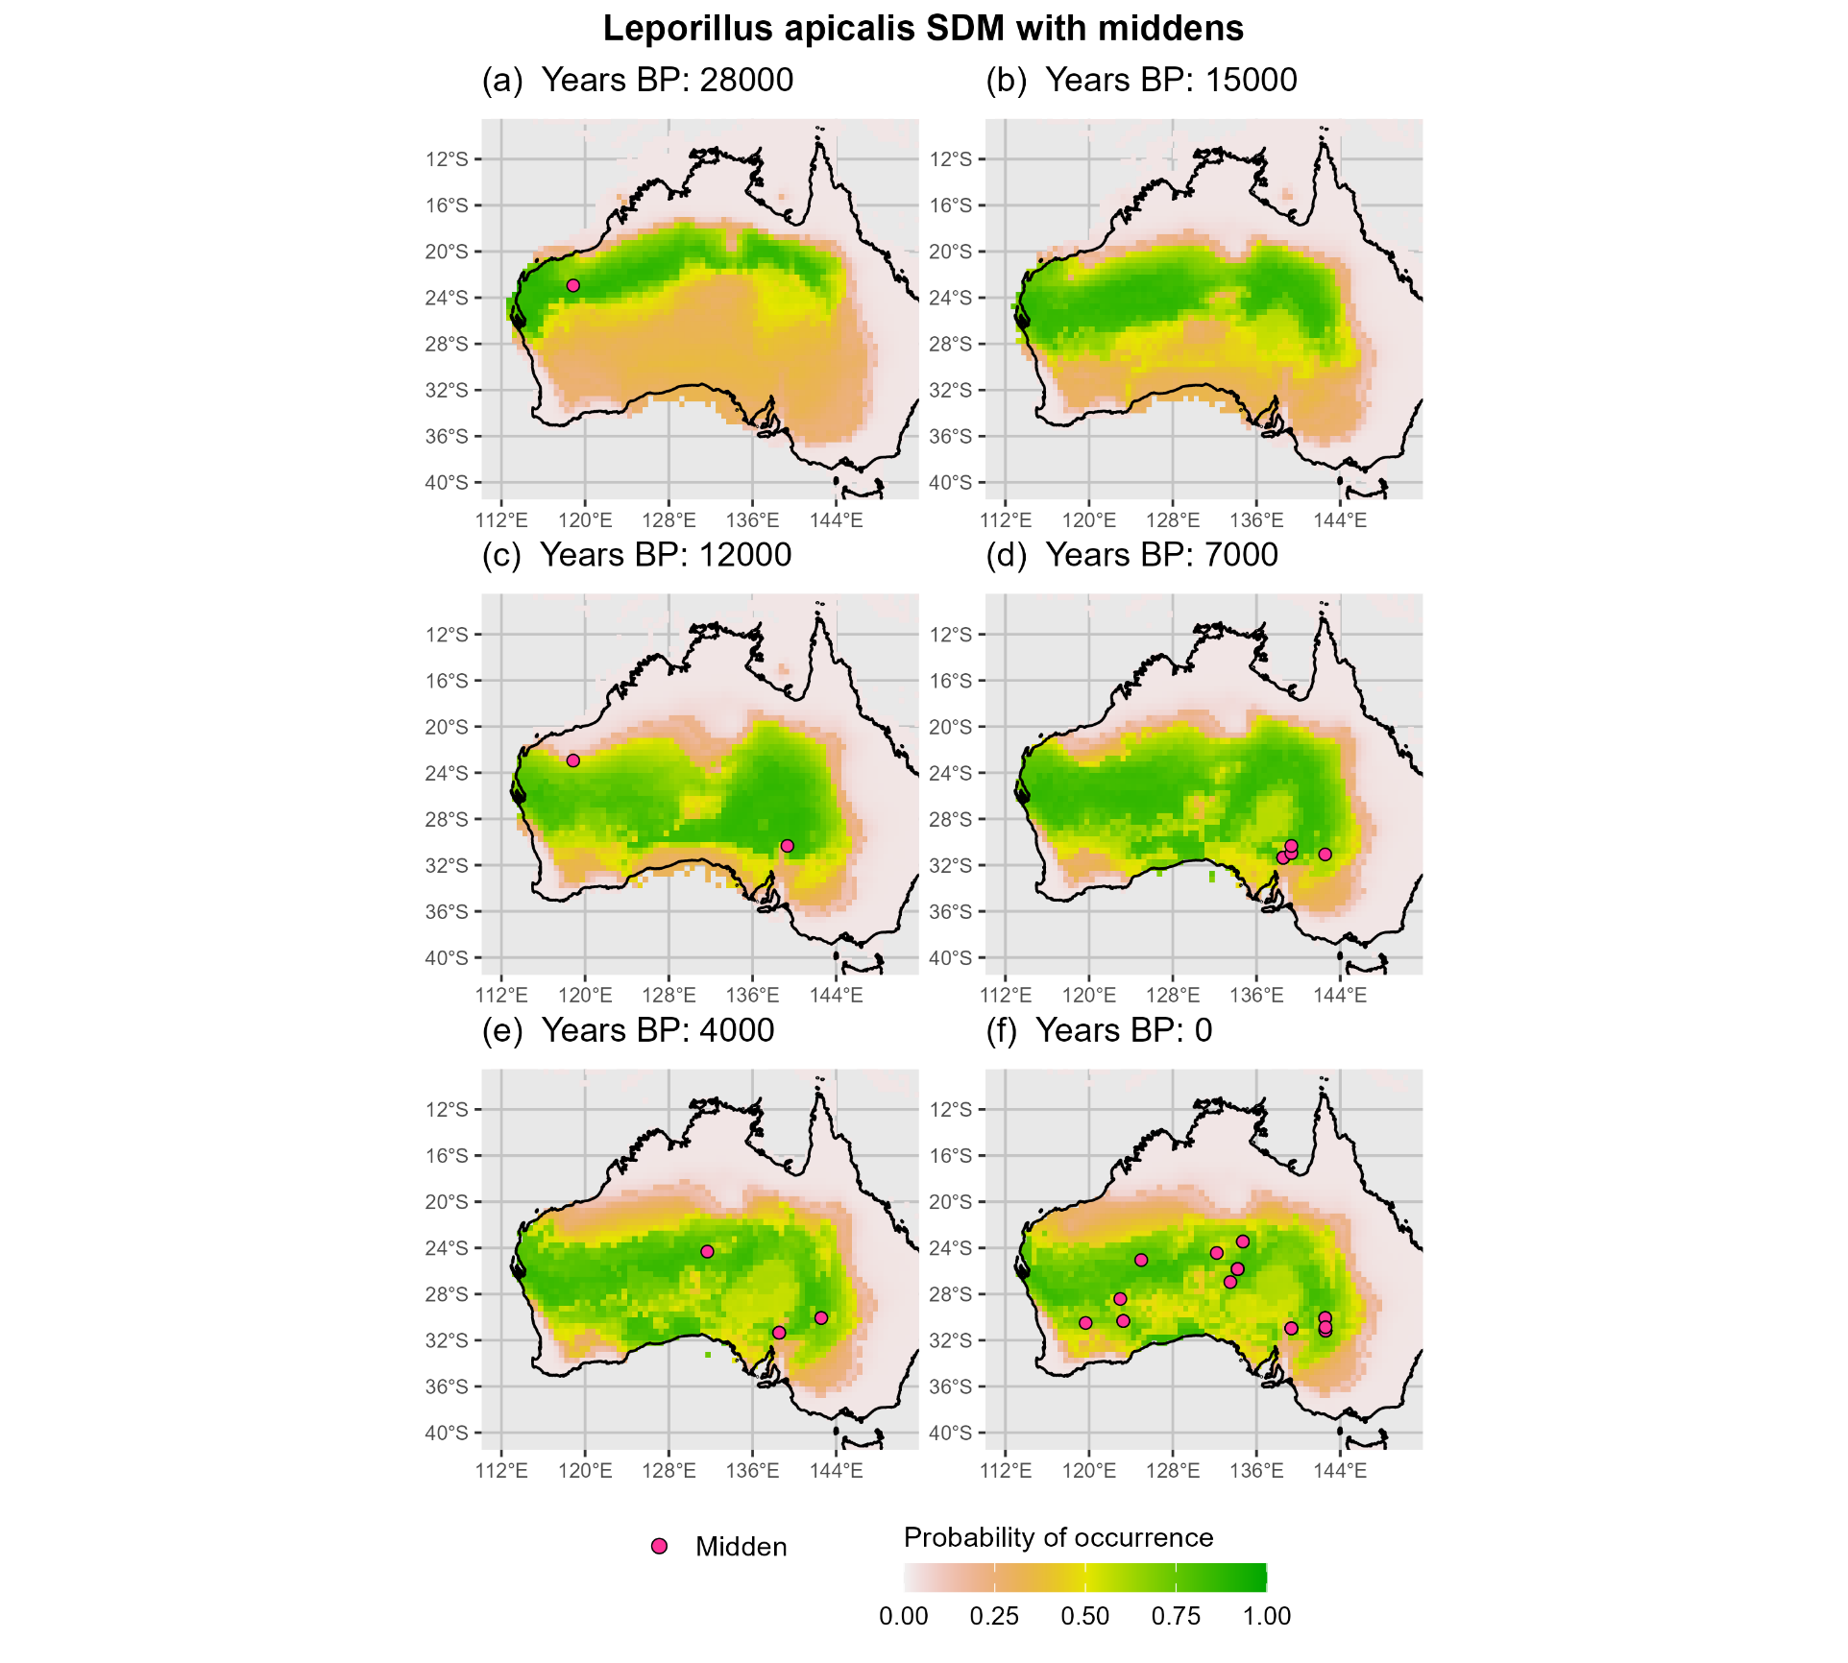
Figure 1. Predicted distribution of Leporillus apicalis across six key time steps from 28 ka to 0 BP. Habitat suitability is shown as a continuous probability surface, with green areas indicating high climatic suitability and warmer colours indicating lower suitability. Pink points show the locations of dated middens corresponding to each time step.
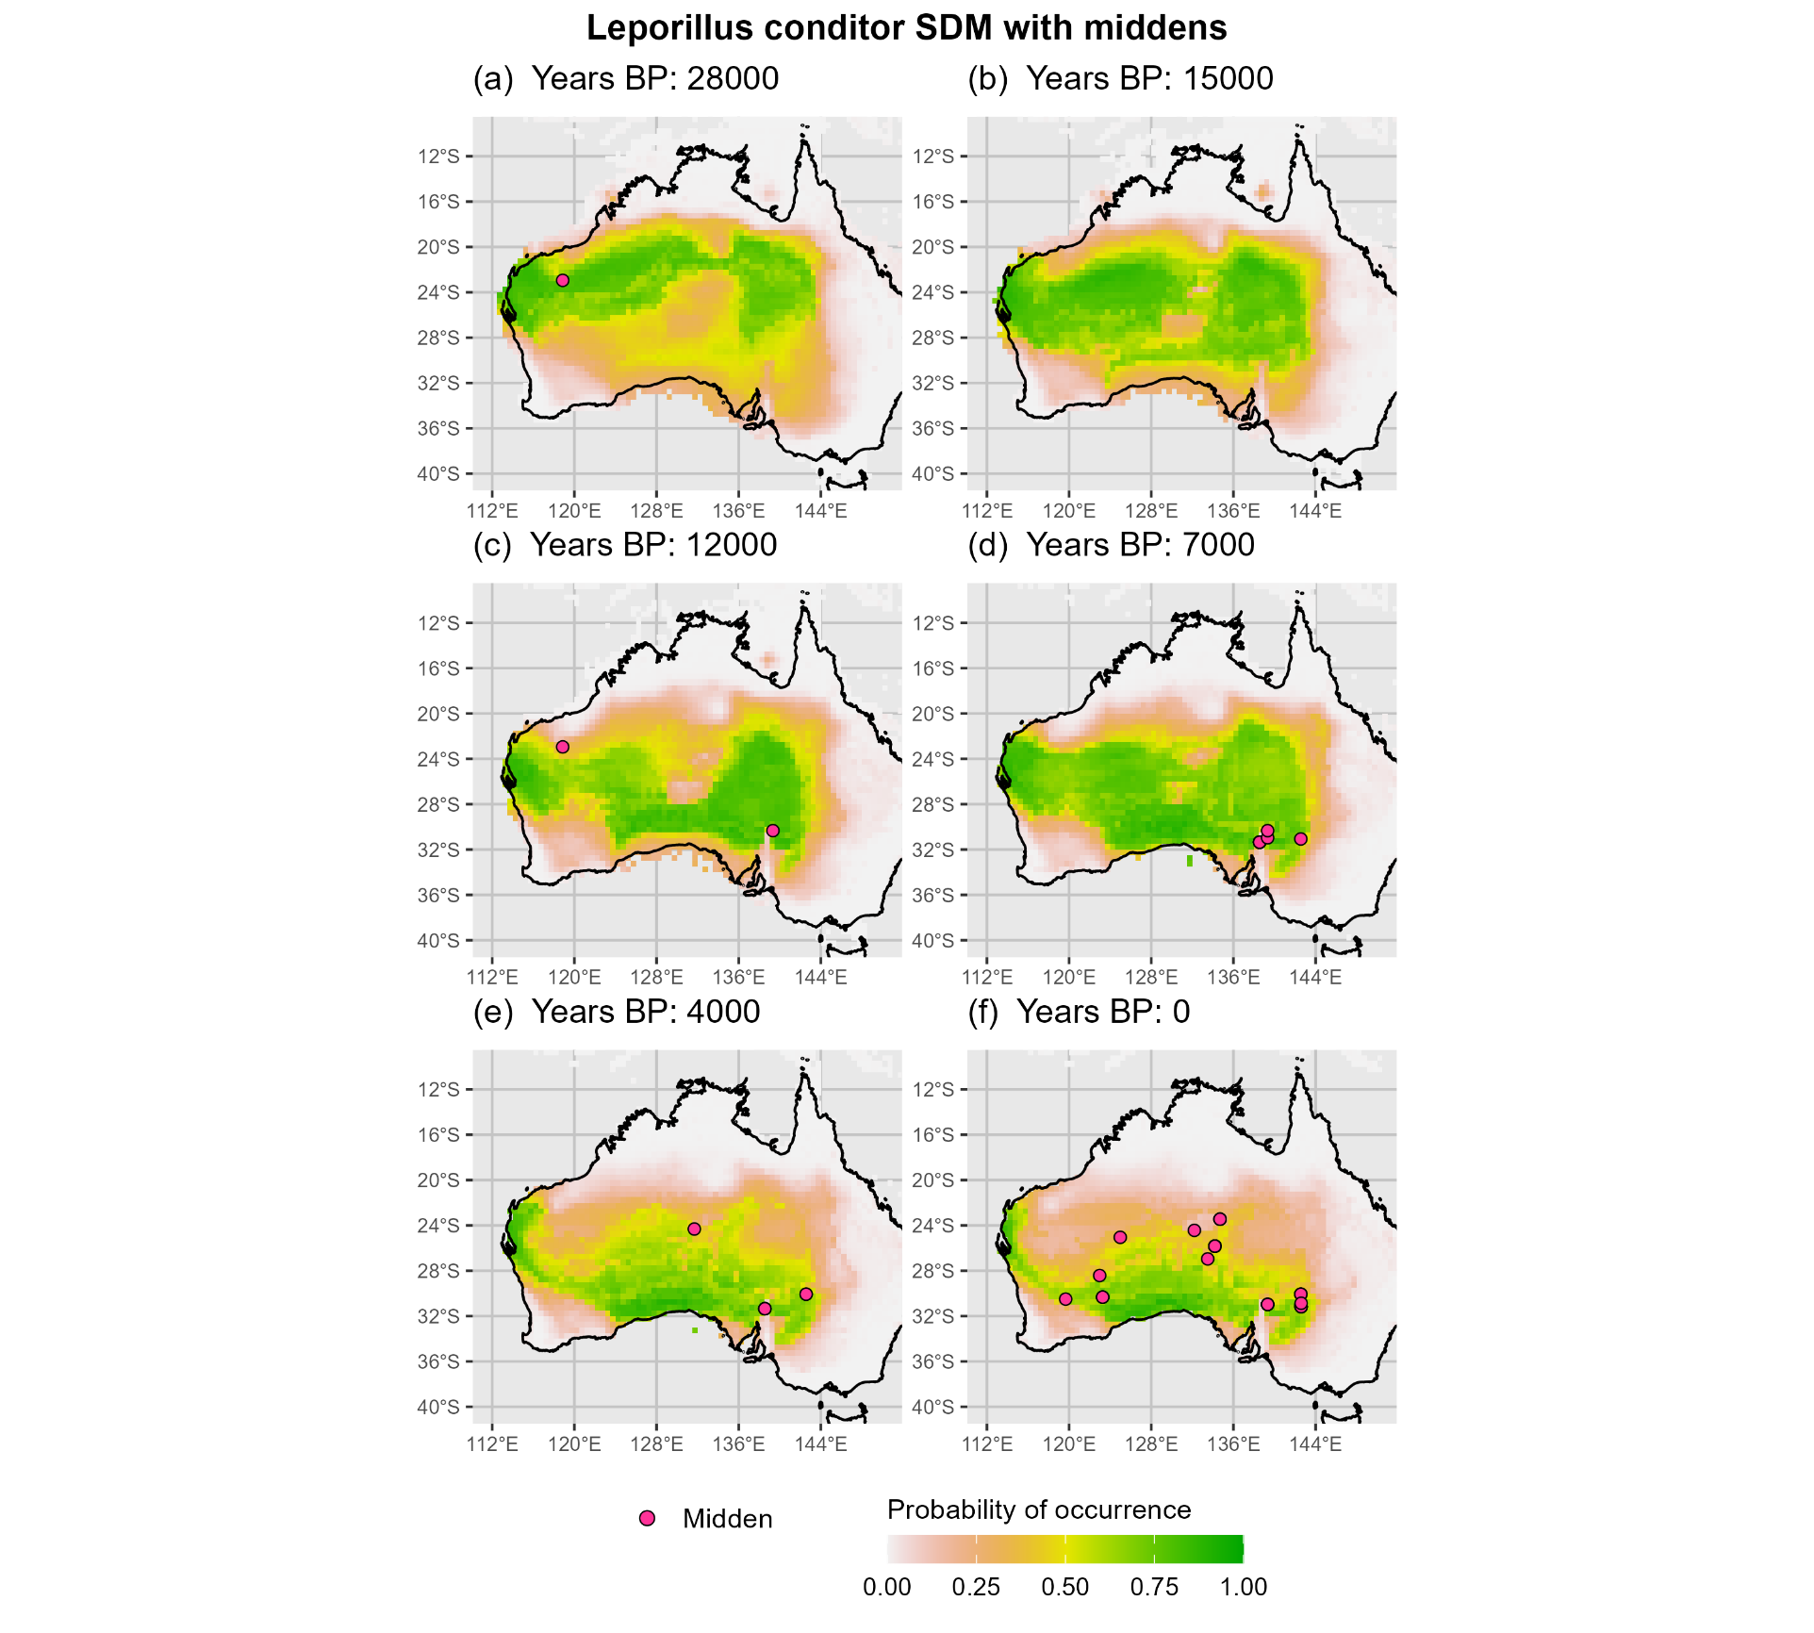
Figure 2. Predicted distribution of Leporillus conditor across six key time steps from 28ka to 0 BP. Habitat suitability is displayed as a continuous probability surface, with green areas representing high climatic suitability.

The modelled suitability-weighted centroids of L. conditor reached their most northerly positions by 23 ka, while the L. apicalis model peaked slightly later at 26 ka (−24.86° for L. apicalis; −24.96° for L. conditor). Between 26 and 21 ka, both species are predicted to have contracted southward in response to intensifying glacial conditions (Figure 3). For the L. apicalis model, this period marked a gradual retraction of northern habitat, particularly across the Top End and eastern interior, resulting in a narrower east–west band of modelled suitability centred between ~20–26°S. The L. conditor model followed a similar pattern of northward contraction but retained a more extensive southern range. By 21 ka, high-suitability conditions were still predicted across a broad swathe of central southern Australia, with core suitability persisting across the inland west and expanding slightly into the Nullarbor. While both models demonstrate habitat loss at the northern margins, the L. conditor model maintained a wider latitudinal envelope and stronger representation in the western interior. Around 133°E, both species showed a pronounced reduction in modelled suitability that formed a low-probability corridor separating higher-suitability areas to the west (central and western interior) from those to the east (Flinders Ranges and adjacent inland South Australia). This constriction in central arid zone connectivity became more distinct between 24 and 21 ka and was particularly pronounced in the L. conditor model.

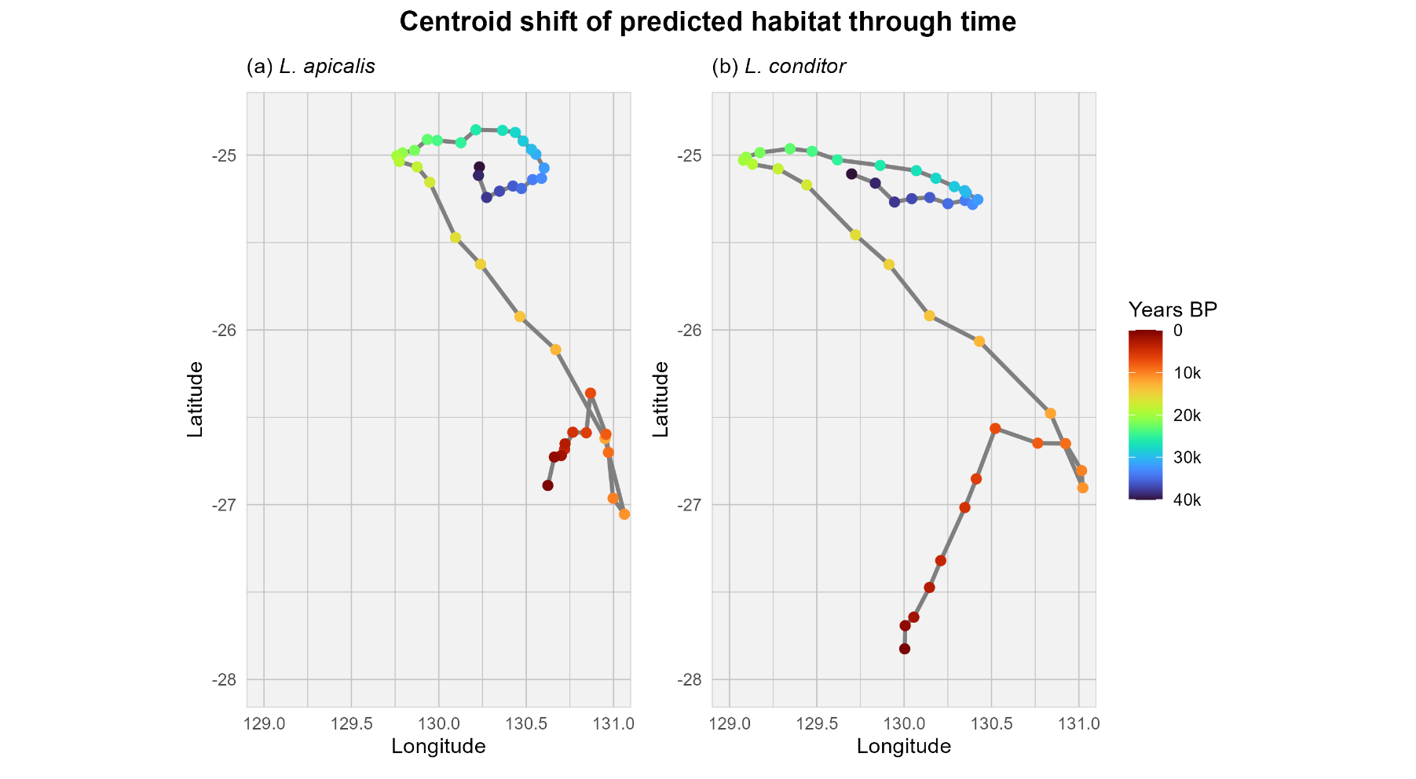
Figure 3. Suitability-weighted centroid movement for (a) Leporillus apicalis and (b) L. conditor over the last 40,000 years, based on species distribution model predictions. Points represent the centroid of predicted habitat suitability at 1,000-year intervals, coloured by time (red = 40 ka, violet = 0). Lines connect sequential centroids.

Between 15 and 8 ka, both models predict southward range expansion, coinciding with post-glacial climatic amelioration. For L. apicalis, modelled suitability increased markedly across the southern interior, extending into the Flinders Ranges, Nullarbor, and parts of southeastern Australia. Although the northern margin of the range remained relatively stable, there was some retraction across the Top End and Queensland interior. By contrast, the L. conditor model shows a more dramatic southern expansion, particularly along the southern coast of Western Australia and into the Nullarbor region, while retaining substantial suitability across the inland west. The two models continued to show overlapping areas of core suitability, but L. apicalis maintained broader longitudinal continuity across the arid zone, while L. conditor exhibited a stronger westward concentration. The low-suitability corridor near 133°E persisted during this interval, especially in the L. conditor model, maintaining a partial separation between eastern and western zones of high suitability.
Between 8 ka and the present, both models show latitudinal contraction, especially due to loss of former northern ranges, becoming increasingly restricted to southern arid and semi-arid regions. However, the L. apicalis model retained broader latitudinal and longitudinal extents, with high suitability spanning much of the central and southern interior and along the west coast, while the L. conditor model showed patchier suitability, largely confined to the southern third of the continent (Figure 1-Figure 2).
These spatial patterns are reflected in the movement of the suitability-weighted centroids (Figure 3; ). Over the 40,000-year period, the centroid of L. apicalis shifted 593.7 km southward, at an average rate of 14.8 km per 1,000 years, with a net bearing of 169.1° (S). L. conditor exhibited a slightly longer and more direct trajectory, shifting 742.2 km at an average rate of 18.6 km per 1,000 years, with a net bearing of 174.3° (S). Although individual stepwise azimuths varied, both species models followed a broadly parallel pattern of southward range movement after the LGM, with centroids stabilising during the mid to late Holocene.

Midden validation
Spatial clustering of dated middens
The distribution of dated midden samples is highly spatially clustered, with most records falling within four core regions: the Pilbara, the Flinders Ranges, central Australia near Alice Springs, and western New South Wales near Broken Hill (Figure 4). Midden collection in the Flinders Ranges and western New South Wales has been spatially concentrated within relatively small areas (~144–388 km²), while central Australian middens are distributed across a much broader area (~44,900 km²), indicating more diffuse sampling. Although precise coordinates for the Pilbara middens are unavailable, they originate from a highly localised area within Banjima Country (McBride et al., 2022).
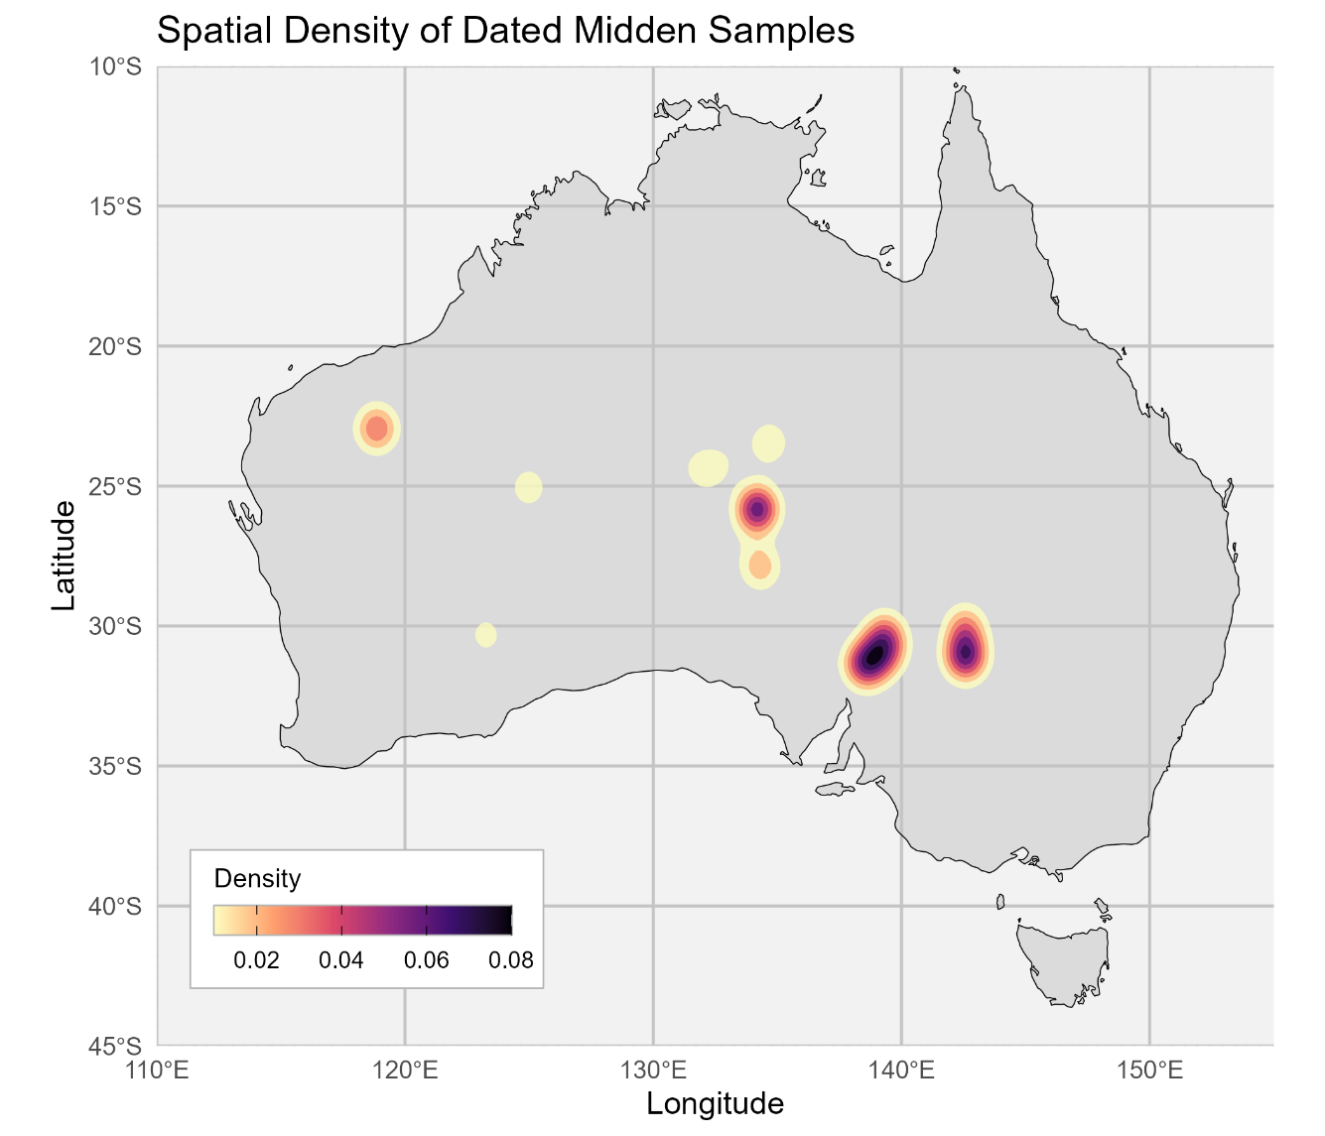

Figure 4. Kernel density estimate showing the spatial distribution of dated midden sampling effort across Australia. Four major clusters are apparent, including the Pilbara, central Australia, the Flinders Ranges, and southeastern Australia. These clusters reflect areas of concentrated sampling and dating, highlighting the spatial bias of available validation data.

As described in Methods, 57 dated middens (not identified to species) were used for external validation and evaluated against both models. Validation metrics indicated moderate predictive skill for both species, with L. apicalis achieving slightly higher scores (TSS = 0.45, Sørensen = 0.48, F₂ = 0.56) than L. conditor (TSS = 0.38, Sørensen = 0.41, F₂ = 0.53) ().

L. apicalis
Except in the Pilbara—where suitability and midden preservation extend into the Pleistocene—the timing of midden appearance aligns with the onset of local climatic suitability as the species expanded southward in the early Holocene. In the Flinders Ranges, the earliest midden appears around 12 ka. In southeastern Australia, midden appearance begins around 7 ka. In central Australia, although suitability is established by around 8 ka, the earliest midden does not appear until around 4 ka (Figure 1).

L. conditor
This pattern is less consistent for the L. conditor model, where only the most southerly clusters align with the predicted range (Figure 2). Midden dates from central Australia fall outside the modelled distribution for L. conditor but correspond to areas and time periods of high suitability in the L. apicalis model, suggesting these middens may be attributable to L. apicalis.
Modelled responses to individual climate variables
Partial dependence plots () show that L. apicalis maintained higher predicted suitability under both warmer maximum temperatures (BIO05) and colder minimum temperatures (BIO06), while L. conditor declined more sharply beyond ~30 °C and below ~10 °C, respectively. Both species showed a strong decline in suitability above ~300 mm annual precipitation (BIO12), but L. conditor retained higher suitability across a broader range of lower rainfall values. This difference is most evident in the zoomed-in precipitation response (d), where L. conditor exhibits a wider peak and slower decline below 700 mm.

Variable importance
Variable importance analysis based on drop-out loss () identified BIO12 (annual precipitation) as the most influential predictor for both species. For L. apicalis, BIO12 contributed the highest increase in model error when removed, followed by BIO06 (minimum temperature of the coldest month) and BIO05 (maximum temperature of the warmest month) (a). L. conditor showed a similar ranking (b), but overall drop-out losses were slightly lower across all variables, suggesting a weaker or more diffuse response to individual predictors.

Table 2. Limitations of Midden-Based Validation
Limitation | Description | Implication for Validation
Spatial bias | Sampling focused on accessible regions (e.g. near Adelaide, Alice Springs, Broken Hill). Large areas remain unsampled. | Limits validation to a narrow, biased subset of the species' former range.
Temporal clustering | Many dates come from a few sites, often producing multiple ages from the same midden. | Artificially inflates sample size and distorts temporal resolution.
Access-driven sampling | Site selection was driven by road access and logistics rather than systematic coverage. | Overrepresents some areas and skews the spatial signal.
Preservation bias | Middens only preserve under specific geological and environmental conditions. | Some suitable areas may leave no datable record.
Taxonomic uncertainty | Most middens are not identified to species. | Prevents species-specific validation against model predictions.

Discussion

Predicted Range Dynamics
The reconstructed distributions of Leporillus apicalis and L. conditor across the late Quaternary reveal broadly similar responses to major climatic transitions, yet consistent differences in timing, range extent, and spatial continuity. Both species contracted northward during the early glacial period and expanded southward following postglacial climatic amelioration. However, L. apicalis maintained a more continuous east–west band of suitable habitat and exhibited a smaller net displacement, suggesting greater persistence within the central arid zone. In contrast, L. conditor showed a larger southward centroid shift and a stronger western bias throughout, consistent with its known association with milder, semi-arid environments (Copley, 1999).
These contrasts align with known ecological differences between the species. Both are ground-dwelling, nest-building rodents associated with shrubland and open woodland habitats. However, L. apicalis appears to have tolerated more thermally variable environments, extending further into the interior (Copley, 1999). This is consistent with partial dependence plots showing higher predicted suitability under both warmer maximum temperatures and colder minimum temperatures (), suggesting broader thermal tolerance than L. conditor. Some historical accounts describe L. apicalis as partially arboreal or inclined to use tree hollows and rocky crevices, though this remains debated. Such nesting behaviours may have aided its persistence across a broader range of temperature conditions. L. conditor, in contrast appears to have had a narrower thermal niche but a broader tolerance to precipitation variability ().

This is notable given that L. apicalis was previously described as the more arid-adapted species, based on its historical range and habitat descriptions. Copley (1999) characterised it as extending further into the arid zone than L. conditor.

Midden Validation
The spatial clustering of dated midden samples highlights how access and logistics have influenced validation potential. In the Flinders Ranges, western New South Wales, and the Pilbara, targeted surveys likely provided representative snapshots of preserved midden ages, while in central Australia, broader and more spatially diffuse sampling makes it less clear whether older middens were absent or simply undetected. This uneven coverage reflects the legacy of survey effort rather than the species’ true historical distributions.
In the Pilbara, modelled persistence of high suitability throughout the glacial period suggests the region may have served as a long-term refugium. This is supported by dated middens extending beyond 20 ka. In the Flinders Ranges, midden accumulation begins around 12 ka, coinciding with predicted increases in suitability. In southeastern Australia, midden dates cluster around 7 ka, matching the timing of postglacial expansion in the L. apicalis model.

These patterns provide strong independent support for the modelled range shifts.
Central Australia presents a different case. Although modelled climatic suitability for L. apicalis is established by 8 ka, midden accumulation does not begin until approximately 4 ka, indicating a temporal lag between the onset of suitable conditions and the appearance of preserved middens. This may reflect stochastic preservation processes or uneven sampling, particularly given that midden collection in central Australia has been more spatially diffuse than in other regions. While the number of dated middens is comparable to those from the Flinders Ranges and western New South Wales, they are spread across a vastly larger area (~44,900 km²), suggesting lower sampling intensity and less focused effort. Despite this, the alignment with L. apicalis predictions is notable. Conversely, the L. conditor model does not predict high suitability in central Australia during the time steps corresponding to the dated middens, making it more likely these were deposited by L. apicalis.
These findings have practical implications for future midden discovery and palaeoecological research. By showing that SDMs can predict where and when climatic conditions were suitable for Leporillus during the Pleistocene, this study provides a tool for locating midden sites beyond historically sampled areas. In the Pilbara, the persistence of high predicted suitability —combined with the presence of dated middens—suggests that this and other climatically similar parts of the western interior may preserve long-term ecological records. These results support the use of palaeo-informed SDMs to guide targeted sampling in under-surveyed regions.
Beyond their palaeoecological value, the models also offer insights relevant to conservation. The contrasting responses of Leporillus apicalis and L. conditor to thermal and precipitation variables challenge earlier assumptions about aridity tolerance and habitat specialisation. While L. apicalis showed broader thermal tolerance, L. conditor persisted under lower precipitation—reversing expectations based on historical range descriptions. These findings refine our understanding of species–environment relationships under both past and future climates, particularly for L. conditor, which is listed as vulnerable and has been the focus of multiple relocation efforts over the past 30 years.

Conclusion
Species distribution modelling of Leporillus apicalis and L. conditor provides new insights into how arid-adapted rodents responded to late Quaternary climatic changes across inland Australia. Despite broadly similar contraction–expansion patterns, the two species exhibited consistent differences in range dynamics, thermal and precipitation tolerances, and predicted refugial persistence. Modelled responses to climatic variables revealed that L. apicalis maintained broader thermal tolerance, whereas L. conditor exhibited a wider tolerance to low annual precipitation, challenging historical assumptions about aridity adaptations.
The spatiotemporal distribution of dated midden samples offers independent support for the modelled predictions, particularly the timing and direction of postglacial expansions. However, spatial bias and uneven sampling intensity remain limitations, especially in central Australia, where preservation and detection are less certain. Overall, these results demonstrate the potential of palaeo-SDM approaches to reconstruct species’ past distributions, guide future midden sampling, and refine understanding of species-environment relationships in Australia’s arid interior.

References
Allen, V., Head, L., Medlin, G., & Witter, D. (2000). Palaeo‐ecology of the Gap and Coturaundee Ranges, western New South Wales, using stick‐nest rat (Leporillus spp.)(Muridae) middens. Austral Ecology, 25(4), 333-343.
Allouche, O., Tsoar, A., & Kadmon, R. (2006). Assessing the accuracy of species distribution models: prevalence, kappa and the true skill statistic (TSS). Journal of applied ecology, 43(6), 1223-1232.
Araújo, M. B., & New, M. (2007). Ensemble forecasting of species distributions. Trends in Ecology & Evolution, 22(1), 42-47.
Barbet-Massin, M., Jiguet, F., Albert, C. H., & Thuiller, W. (2012). Selecting pseudo-absences for species distribution models: how, where and how many? Methods in Ecology and Evolution, 3(2), 327-338. https://doi.org/https://doi.org/10.1111/j.2041-210X.2011.00172.x
Betancourt, J. (2004). Advances in arid lands bigeography: the rodent midden record in the Americas. In M. V. Lomolino & L. R. Heaney (Eds.), Frontiers of biogeography: new directions in the geography of nature. Sinauer Associates Sunderland.
Betancourt, J. L. (1987). Paleoecology of pinyon-juniper woodlands: summary. General technical report INT-US Department of Agriculture, Forest Service, Intermountain Research Station (USA).
Betancourt, J. L., & Van Devender, T. R. (1981). Holocene vegetation in Chaco Canyon, New Mexico. Science, 214(4521), 656-658.
Betancourt, J. L., Van Devender, T. R., & Martin, P. S. (1990). Packrat middens: the last 40,000 years of biotic change. University of Arizona Press.
Biecek, P. (2018). DALEX: Explainers for Complex Predictive Models in R. In CRAN. https://jmlr.org/papers/v19/18-416.html
Bird, M. I., Condie, S. A., o’Connor, S., o’Grady, D., Reepmeyer, C., Ulm, S., Zega, M., Saltré, F., & Bradshaw, C. J. (2019). Early human settlement of Sahul was not an accident. Scientific Reports, 9(1), 8220.
Birks, H. H. (2001). Plant Macrofossils. In J. P. Smol, H. J. B. Birks, W. M. Last, R. S. Bradley, & K. Alverson (Eds.), Tracking Environmental Change Using Lake Sediments: Terrestrial, Algal, and Siliceous Indicators (pp. 49-74). Springer Netherlands. https://doi.org/10.1007/0-306-47668-1_4
Bradshaw, C., Johnson, C. N., Llewelyn, J., Weisbecker, V., Strona, G., & Saltré, F. (2021). Relative demographic susceptibility does not explain the extinction chronology of Sahul’s megafauna. Elife, 10, e63870.
Bradshaw, C., Norman, K., Ulm, S., Williams, A. N., Clarkson, C., Chadœuf, J., Lin, S. C., Jacobs, Z., Roberts, R. G., & Bird, M. I. (2021). Stochastic models support rapid peopling of Late Pleistocene Sahul. Nature Communications, 12(1), 2440.
Bradshaw, C., Ulm, S., Williams, A. N., Bird, M. I., Roberts, R. G., Jacobs, Z., Laviano, F., Weyrich, L. S., Friedrich, T., & Norman, K. (2019). Minimum founding populations for the first peopling of Sahul. Nature Ecology & Evolution, 3(7), 1057-1063.
Breiman, L. (2001). Random forests. Machine learning, 45, 5-32.
Christophel, D. C., & Lys, S. (1986). Mummified leaves of two new species of Myrtaceae from the Eocene of Victoria, Australia. Australian Journal of Botany, 34(6), 649-662.
Clark, P. U., Dyke, A. S., Shakun, J. D., Carlson, A. E., Clark, J., Wohlfarth, B., Mitrovica, J. X., Hostetler, S. W., & McCabe, A. M. (2009). The last glacial maximum. Science, 325(5941), 710-714.
Copley, P. (1999). Natural histories of Australia’s stick-nest rats, genus Leporillus (Rodentia: Muridae). Wildlife Research, 26(4), 513-539. https://doi.org/https://doi.org/10.1071/WR97056
Da Re, D., Tordoni, E., Lenoir, J., Lembrechts, J., Vanwambeke, S., Rocchini, D., & Bazzichetto, M. (2023). USE it: uniformly sampling pseudo-absences within the environmental space for applications in habitat suitability models. In CRAN. https://doi.org/10.32942/X2XS32
Ehleringer, J., & Mooney, H. (1983). Productivity of desert and Mediterranean-climate plants. In Physiological Plant Ecology IV: Ecosystem Processes: Mineral Cycling, Productivity and Man’s Influence (pp. 205-231). Springer.
Elias, S. (2013). Encyclopedia of Quaternary science. Newnes.
Elith, J., & Leathwick, J. R. (2009). Species distribution models: ecological explanation and prediction across space and time. Annual review of ecology, evolution, and systematics, 40(1), 677-697.
Faegri, K., & Iversen, J. (1975). Textbook of pollen analysis.
Frick, H., Chow, F., Kuhn, M., Mahoney, M., Silge, J., & Wickham, H. (2024). rsample: General Resampling Infrastructure. In CRAN. https://CRAN.R-project.org/package=rsample
Friedman, J. H. (2001). Greedy function approximation: a gradient boosting machine. Annals of statistics, 1189-1232.
Gastaldo, R. A., & Demko, T. M. (2011). The relationship between continental landscape evolution and the plant-fossil record: long term hydrologic controls on preservation. Taphonomy: Process and bias through time, 249-285.
Gibbard, P. L., & Head, M. (2020). The quaternary period. In Geologic time scale 2020 (pp. 1217-1255). Elsevier.
Graham, R. W., & Grimm, E. C. (1990). Effects of global climate change on the patterns of terrestrial biological communities. Trends in Ecology & Evolution, 5(9), 289-292.
Green, N., Caldwell, J., Hope, J., & Luly, J. (1983). Pollen from an 1800 year old stick-nest rat midden from Gnalta, Western New South Wales. Quaternary Australia, 1, 31-41.
Hastie, T., & Tibshirani, R. (1986). Generalized Additive Models. Statistical Science, 1(3), 297-310. http://www.jstor.org/stable/2245459
Head, M. J. (2019). Formal subdivision of the Quaternary System/Period: Present status and future directions. Quaternary International, 500, 32-51.
Hernangómez, D. (2023). Using the {tidyverse} with {terra} objects: the {tidyterra} package. In The Open Journal. https://doi.org/10.21105/joss.05751
Hijmans, R. J. (2024a). geosphere: Spherical Trigonometry. In CRAN. https://CRAN.R-project.org/package=geosphere
Hijmans, R. J. (2024b). terra: Spatial Data Analysis. In CRAN. https://CRAN.R-project.org/package=terra
Hirzel, A. H., Le Lay, G., Helfer, V., Randin, C., & Guisan, A. (2006). Evaluating the ability of habitat suitability models to predict species presences. Ecological modelling, 199(2), 142-152.
Hope, G. (1994). Quaternary vegetation. In ‘History of the Australian Vegetation: Cretaceous to Recent’.(Ed. RS Hill.) pp. 368–389. In: Cambridge University Press: Cambridge.
Iturbide, M., Bedia, J., Herrera, S., del Hierro, O., Pinto, M., & Gutiérrez, J. M. (2015). A framework for species distribution modelling with improved pseudo-absence generation. Ecological modelling, 312, 166-174. https://doi.org/https://doi.org/10.1016/j.ecolmodel.2015.05.018
Johnson, C. N. (2009). Ecological consequences of Late Quaternary extinctions of megafauna. Proceedings of the Royal Society B: Biological Sciences, 276(1667), 2509-2519.
Johnson, C. N., Prior, L. D., Archibald, S., Poulos, H. M., Barton, A. M., Williamson, G. J., & Bowman, D. M. (2018). Can trophic rewilding reduce the impact of fire in a more flammable world? Philosophical Transactions of the Royal Society B: Biological Sciences, 373(1761), 20170443.
Juggins, S., & Birks, H. J. B. (2012). Quantitative environmental reconstructions from biological data. Tracking environmental change using lake sediments: Data handling and numerical techniques, 431-494.
Kraehe, A. G., Weisbecker, V., Hill, R. R., & Hill, K. E. (2024). Threatened stick-nest rats preferentially eat invasive boxthorn rather than native vegetation on Australia’s Reevesby Island. Wildlife Research, 51(8), -. https://doi.org/https://doi.org/10.1071/WR23140
Kuhn, M. (2024). tune: Tidy Tuning Tools. In CRAN. https://CRAN.R-project.org/package=tune
Kuhn, M., & Couch, S. (2024). workflowsets: Create a Collection of 'tidymodels' Workflows. In CRAN. https://CRAN.R-project.org/package=workflowsets
Kuhn, M., & Frick, H. (2024). dials: Tools for Creating Tuning Parameter Values. In CRAN. https://CRAN.R-project.org/package=dials
Kuhn, M., & Vaughan, D. (2024). parsnip: A Common API to Modeling and Analysis Functions. In CRAN. https://CRAN.R-project.org/package=parsnip
Kuhn, M., & Wickham, H. (2020). Tidymodels: a collection of packages for modeling and machine learning using tidyverse principles. In CRAN. https://www.tidymodels.org
Lanner, R. M., Van Devender, T. R., & Richardson, D. (1998). The recent history of pinyon pines in the American Southwest. Cambridge University Press.
Lazagabaster, I. A., Thomas, C. D., Spedding, J. V., Ikram, S., Solano‐Regadera, I., Snape, S., & Bro‐Jørgensen, J. (2024). Evaluating species distribution model predictions through time against paleozoological records. Ecology and evolution, 14(10), e70288.
Leonardi, M., Colucci, M., Pozzi, A., & Manica, A. (2024). tidysdm: Species Distribution Models with Tidymodels. In CRAN. https://CRAN.R-project.org/package=tidysdm
Leonardi, M., Colucci, M., Pozzi, A. V., Scerri, E. M., & Manica, A. (2023). Tidysdm: Leveraging the flexibility of tidymodels for species distribution modelling in R. bioRxiv, 2023.2007. 2024.550358.
Leonardi, M., Hallett, E. Y., Beyer, R., Krapp, M., & Manica, A. (2023). pastclim 1.2: an R package to easily access and use paleoclimatic reconstructions. Ecography, 2023(3), e06481. https://doi.org/https://doi.org/10.1111/ecog.06481
Lesser, M. R., & Jackson, S. T. (2011). Reliability of macrofossils in woodrat (Neotoma) middens for detecting low-density tree populations. Paleobiology, 37(4), 603-615.
Liang, W., Papeş, M., Tran, L., Grant, J., Washington-Allen, R., Stewart, S., & Wiggins, G. (2018). The effect of pseudo-absence selection method on transferability of species distribution models in the context of non-adaptive niche shift. Ecological modelling, 388, 1-9. https://doi.org/https://doi.org/10.1016/j.ecolmodel.2018.09.018
Lisiecki, L. E., & Raymo, M. E. (2005). A Pliocene‐Pleistocene stack of 57 globally distributed benthic δ18O records. Paleoceanography, 20(1).
Lyford, M. E., Jackson, S. T., Gray, S. T., & Eddy, R. G. (2004). Validating the use of woodrat (Neotoma) middens for documenting natural invasions. Journal of Biogeography, 31(2), 333-342. https://doi.org/https://doi.org/10.1046/j.0305-0270.2003.00987.x
Manica, A. (2023). tidysdm overview. https://evolecolgroup.github.io/tidysdm/articles/a0_tidysdm_overview.html
Marmion, M., Parviainen, M., Luoto, M., Heikkinen, R. K., & Thuiller, W. (2009). Evaluation of consensus methods in predictive species distribution modelling. Diversity and distributions, 15(1), 59-69.
McBride, E., Wallis, L. A., Hopf, F., Haberle, S. G., & Dardengo, M. (2022). Demonstrating the potential of amberat middens for understanding late Quaternary palaeoenvironments in the Central Pilbara, western Australia. Quaternary International, 634, 99-110. https://doi.org/https://doi.org/10.1016/j.quaint.2022.05.009
McCarthy, L., & Head, L. (2001). Holocene variability in semi-arid vegetation: new evidence from Leporillus middens from the Flinders Ranges, South Australia. The Holocene, 11(6), 681-689.
McCarthy, L., Head, L., & Quade, J. (1996). Holocene palaeoecology of the northern Flinders ranges, south Australia, based on stick-nest rat (Leporillus spp) middens: A preliminary overview. Palaeogeography Palaeoclimatology Palaeoecology, 123(1-4), 205-218. https://doi.org/https://doi.org/10.1016/0031-0182(96)01113-3
McCullagh, P., & Nelder, J. A. (1989). Binary data. In Generalized linear models (pp. 98-148). Springer.
Nogués-Bravo, D., Rodríguez, J., Hortal, J., Batra, P., & Araújo, M. B. (2008). Climate change, humans, and the extinction of the woolly mammoth. PLoS biology, 6(4), e79.
Nogués‐Bravo, D. (2009). Predicting the past distribution of species climatic niches. Global Ecology and Biogeography, 18(5), 521-531.
Pearson, S. (1999). Late Holocene biological records from the middens of stick-nest rats in the central Australian arid zone. Quaternary International, 59(1), 39-46. https://doi.org/https://doi.org/10.1016/S1040-6182(98)00070-6
Pearson, S., & Betancourt, J. L. (2002). Understanding arid environments using fossil rodent middens. Journal of Arid Environments, 50(3), 499-511. https://doi.org/https://doi.org/10.1006/jare.2001.0901
Pearson, S., & Dodson, J. R. (1993). Stick-Nest Rat Middens as Sources of Paleoecological Data in Australian Deserts. Quaternary Research, 39(3), 347-354. https://doi.org/https://doi.org/10.1006/qres.1993.1041
Pearson, S., Lawson, E., Head, L., McCarthy, L., & Dodson, J. (1999). The spatial and temporal patterns of stick-nest rat middens in Australia. Radiocarbon, 41(3), 295-308.
Pebesma, E. (2018). {Simple Features for R: Standardized Support for Spatial Vector Data}. In CRAN. https://doi.org/10.32614/RJ-2018-009
Pillans, B., & Gibbard, P. (2012). The quaternary period. In The geologic time scale 2012. Elsevier.
Polechová, J., & Storch, D. (2008). Ecological niche. Encyclopedia of ecology, 2, 1088-1097.
R Core Team. (2010). R: A language and environment for statistical computing. (No Title).
Rule, S., B.W., B., G., H. S., M., T. C. S., P., K. A., & Johnson, C. N. (2012). The aftermath of megafaunal extinction: Ecosystem transformation in Pleistocene Australia. Science, 335, 1483–1486. https://doi.org/10.1126/science.1214261
Saltré, F., Rodríguez-rey, M., Brook, B. W., Johnson, C. N., Turney, C. S. M., Alroy, J., Cooper, A., Beeton, N., Bird, M. I., Fordham, D. A., Gillespie, R., Herrando-pérez, S., Jacobs, Z., Miller, G. H., Nogués-bravo, D., Prideaux, G. J., Roberts, R. G., & Bradshaw, C. J. A. (2016). Climate change not to blame for late Quaternary megafauna extinctions in Australia. Nature Communications, 7, 10511. https://doi.org/https://doi.org/10.1038/ncomms10511
Scaife, R. (1998). Pollen analysis.
Sharma, M. (1976). Soil water regimes and water extraction patterns under two semi‐arid shrub (Atriplex spp.) communities. Australian journal of ecology, 1(4), 249-258.
Sharma, M. (1982). Aspects of salinity and water relations of Australian chenopods. In Contributions to the Ecology of Halophytes (pp. 155-172). Springer.
South, A. (2011). rworldmap: A New {R} package for Mapping Global Data. In CRAN. https://journal.r-project.org/articles/RJ-2011-006/
Spicer, R. A. (1991). Plant taphonomic processes. In Taphonomy: releasing the data locked in the fossil record (Vol. 9, pp. 71-113).
Swets, J. A. (1988). Measuring the accuracy of diagnostic systems. Science, 240(4857), 1285-1293.
Van Devender, T. R., & Spaulding, W. G. (1979). Development of vegetation and climate in the southwestern United States. Science, 204(4394), 701-710. https://doi.org/10.1126/science.204.4394.70
Varela, S., Lima-Ribeiro, M. S., & Terribile, L. C. (2015). A short guide to the climatic variables of the last glacial maximum for biogeographers. PloS one, 10(6), e0129037.
Webeck, K., & Pearson, S. (2005). Stick-nest rat middens and a late-Holocene record of White Range, central Australia. Holocene, 15(3), 466-471. https://doi.org/https://doi.org/10.1191/0959683605hl822rr
Wells, P. V., & Jorgensen, C. D. (1964). Pleistocene wood rat middens and climatic change in Mohave Desert: a record of juniper woodlands. Science, 143(3611), 1171-1174.
Wickham, H. (2016). ggplot2: Elegant Graphics for Data Analysis. In Springer-Verlag New York. https://ggplot2.tidyverse.org
Wickham, H., François, R., Henry, L., Müller, K., & Vaughan, D. (2023). dplyr: A Grammar of Data Manipulation. In CRAN. https://CRAN.R-project.org/package=dplyr
Wickham, H., & Henry, L. (2023). purrr: Functional Programming Tools. In CRAN. https://CRAN.R-project.org/package=purrr
Wickham, H., Vaughan, D., & Girlich, M. (2024). tidyr: Tidy Messy Data. In CRAN. https://CRAN.R-project.org/package=tidyr
Wisz, M. S., & Guisan, A. (2009). Do pseudo-absence selection strategies influence species distribution models and their predictions? An information-theoretic approach based on simulated data. BMC Ecology, 9(1), 8. https://doi.org/10.1186/1472-6785-9-8

see vignette: https://evolecolgroup.github.io/tidysdm/articles/a1_palaeodata_application.html

